Analysis of ‘Laptop’ Dataset

- Introduction

Description:
This dataset contains information about various laptops available in the market. The data was collected by scraping information from an e-commerce website. The dataset includes features such as the model name, brand, processor name, RAM, SSD, hard disk size, operating system, graphics card, screen size, resolution, number of cores, number of threads, and a spec score. The price of each laptop is also included in the dataset.

Objective of the analysis:

1. Price Analysis Focus
“To study the distribution of laptop prices and compare pricing across different brands.”
- Brand vs Price (bar chart)
- Price distribution (histogram)
- Boxplot for brand pricing

2. Performance vs Price
“To analyse the relationship between performance-related features (RAM, CPU, GPU) and laptop price.”
- RAM vs Price (scatter)
- CPU type vs Price (boxplot)
- SSD vs HDD impact

3. Budget Segmentation

“To categorize laptops into budget, mid-range, and premium segments and analyse their features.”
- Grouping using price ranges
- Compare specs across segments

- Dataset Description

Dataset Source: https://www.kaggle.com/datasets/sushmita36/laptops dataset?resource=download

Number of records and attributes:

model_name: The name of the laptop model.
brand: The brand of the laptop.
processor_name: The name of the processor used in the laptop.
ram(GB): The amount of RAM (in GB) in the laptop.
ssd(GB): The size of the Solid State Drive (in GB) in the laptop, with 0 indicating no SSD.
Hard Disk(GB): The size of the Hard Disk Drive (in GB) in the laptop, with 0 indicating no hard disk.
Operating System: The operating system installed on the laptop.
graphics: The name of the graphics card used in the laptop.
screen_size(inches): The size of the screen (in inches) of the laptop.
resolution (pixels): The screen resolution (in pixels) of the laptop.
no_of_cores: The number of processor cores in the laptop, with 0 indicating missing information.
no_of_threads: The number of threads in the processor of the laptop, with 0 indicating missing information.
spec_score: A score based on the specifications of the laptop, where a higher score indicates better performance, with 0 indicating missing information.
price: The price of the laptop.

- Data Preprocessing

Enhancing the dataset by creating new columns:

- Price Category:
A new column price_category was created to classify laptops into three segments based on their price:
- Budget (less than ₹50,000)
- Mid-range (₹50,000 to ₹1,00,000)
- Premium (above ₹1,00,000)
This categorization helps in analysing trends across different pricing segments.

- CPU Type Extraction:
The processor_name column contained complex and varied strings.
To simplify analysis, a new column cpu_type was created by extracting key processor categories such as Intel i3, i5, i7 and AMD Ryzen 3, 5, 7

- Storage Type Classification:
A new column storage_type was created to group laptops based on their storage:
- SSD (only SSD present)
- HDD (only Hard Disk present)
- Hybrid (both SSD and HDD present)
This classification helps in understanding how storage type influences pricing and performance.

Grouping and Aggregating data:

To identify patterns and trends in the dataset:

  - By brand to calculate the average price of laptops for each brand.
  - By RAM was performed to analyse how price varies with memory size.
  - Based on price_category to examine how average RAM differs.

- Visualization and Analysis

Brand vs Average Price (Bar Chart)
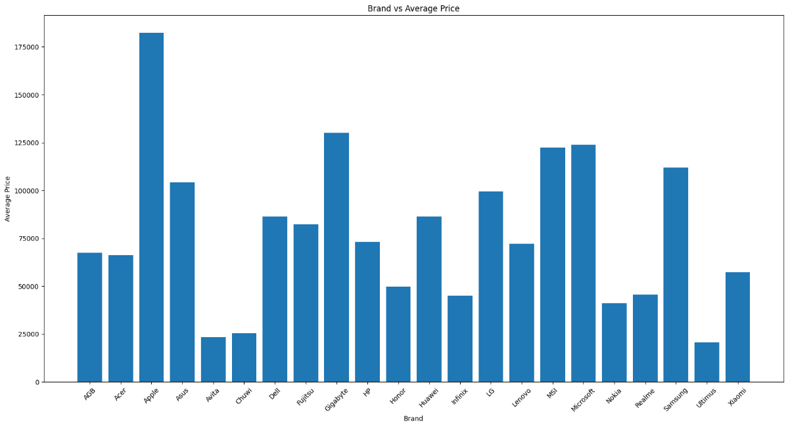
Explanation:
This bar chart shows the average price of laptops for different brands. It can be observed that certain brands have higher average prices compared to others, indicating their focus on premium or high-performance devices.

Price Distribution (Histogram)
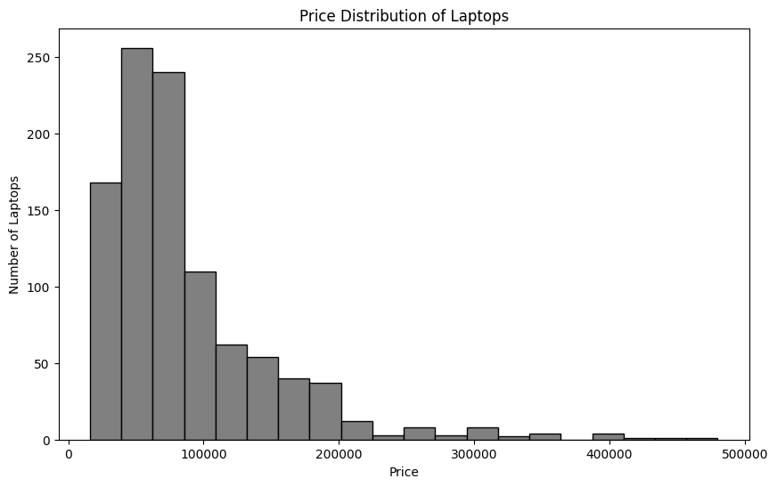
Explanation:
The histogram shows the distribution of laptop prices. Most laptops are concentrated in the mid-price range, with fewer laptops in the very high or very low-price categories.

Price Variation Across Brands (Box Plot)
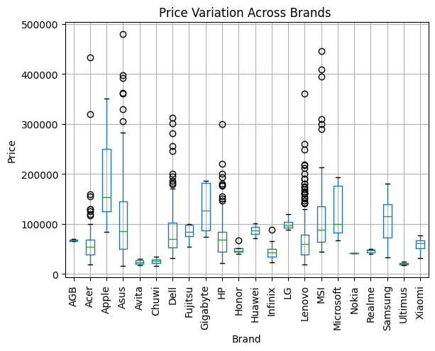
Explanation:
The boxplot highlights the spread and variation of prices within each brand. Some brands show a wide range of prices, indicating they offer both budget and premium models.

RAM vs Price (Scatter Plot)
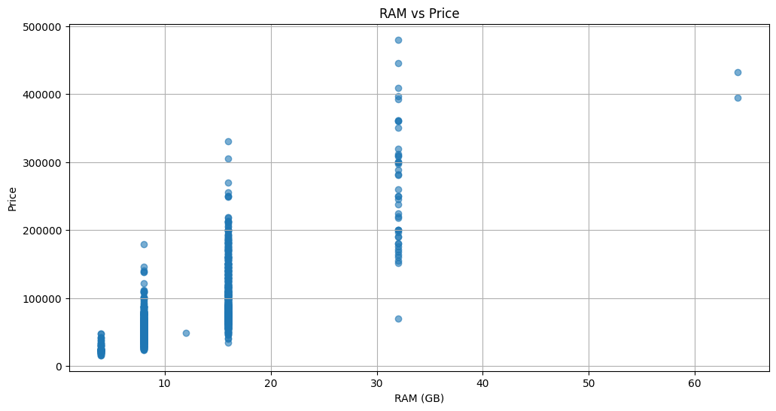
Explanation:
This scatter plot shows the relationship between RAM and price. There is a positive trend where laptops with higher RAM tend to have higher prices.

CPU Type vs Price (Box Plot)
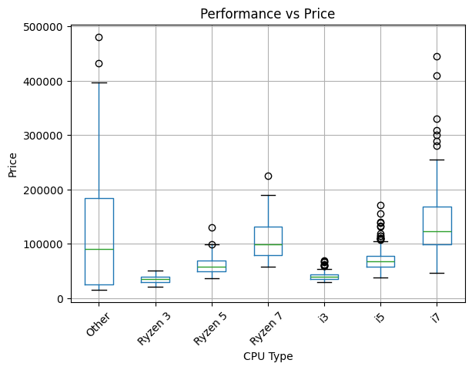
Explanation:
This visualization compares laptop prices across different CPU types. Higher-end processors like i7 and Ryzen 7 generally correspond to higher price ranges.

Price Category vs RAM (Bar Chart)
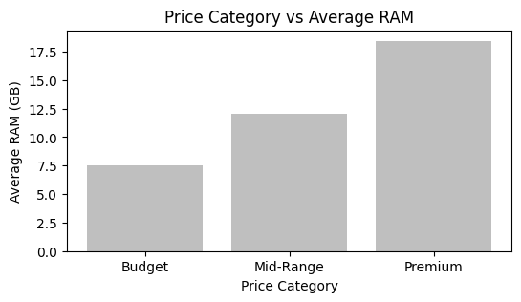
Explanation:
This chart shows how RAM varies across budget segments. Premium laptops tend to have higher RAM compared to budget laptops.

- Key Insights

Based on the visualizations and analysis performed on the laptop dataset, the following key insights were observed:

Price Distribution Trends
- Most laptops fall within the mid-range price category, indicating a higher demand for moderately priced devices.
- Very few laptops are present in the extreme low and high price ranges.

Brand-wise Pricing Patterns
- Certain brands have a higher average price, suggesting a focus on premium or high-performance laptops.
- Other brands offer a wider range of prices, catering to both budget and premium segments.

RAM vs Price Relationship
- A clear positive relationship is observed between RAM and price.
- Laptops with higher RAM (16GB and above) tend to be significantly more expensive than those with lower RAM.

Processor Impact on Price
- Laptops with high-end processors (i7, Ryzen 7) generally fall in the premium price category.
- Entry-level processors like i3 and Ryzen 3 are mostly found in budget laptops.

Storage Type Influence
- Laptops with SSD storage are more common and tend to be priced higher than HDD-based laptops.
- Hybrid storage systems (SSD + HDD) are usually found in mid-range to premium laptops.

Budget Segmentation Insights
- Budget laptops typically have lower RAM and basic specifications.
- Mid-range laptops offer a balance between performance and price.
- Premium laptops include high RAM, better processors, and advanced features.

- Conclusion
The analysis of the laptop dataset revealed that price is strongly influenced by key specifications such as RAM, processor type, and storage configuration. Premium laptops generally offer higher performance features, while budget laptops focus on affordability. Visualization techniques helped in identifying trends, patterns, and relationships within the dataset, making it easier to understand the factors affecting laptop pricing.

